Bachelor of Education (Elementary) &

Bachelor of Education (Secondary) STEM

Unit Plan Template

Unit Title: | Community R, R, N, W | Number of Lessons | 4 | Time  (in weeks): | 1
Name: | Kaylea Prosser | Subject(s): | Social Studies/ ELA | Grade(s): | 2-3

Rationale
The goal of this unit is for students to understand what members make up a community and how their roles and responsibilities are connected to their needs and wants within the community. This unit plan allows for students to understand how each member plays an important role within the community and how their needs are also met. This unit plan allows for students to create a deeper understanding of how roles, responsibilities, needs and wants are different in different communities. This will be shown by comparing an average community to the Secwepemc community. This unit is important to me as it will help students start to understand their role within their community as well those important to them.

Overview:
This unit will start of by students remembering what a community is and looking at a slideshow of different communities around the world. After this, students will start to dive into what roles are within a community such as a doctor, teacher, firefighter etc. In a whole class discussion students will be moving around and discussion what their role in the community is. After lesson one students will move into learning about needs and wants, what the difference between them are and what happens when those aren’t being met. Into lesson three students will be exploring the local Secwepemc Community and their needs and wants and what similarities and differences they share. This lesson will highlight the importance of the land, shelter and community. Finishing off the unit, lesson four is where students will be building their own community. Students will decide what they want to be when they grow up and fill out their community member. Once completed, students will share what they want to be, and they will be posted in the classroom.

CORE COMPETENCIES
Communication | Thinking | Personal & Social
Students engage in informal and structured conversations in which they listen, contribute, develop understanding and relationships, and learn to consider diverse perspectives. | - Critical thinking  Students apply critical, metacognitive, and reflective thinking in given situations, and relate this thinking to other experiences, using this process to identify ways to improve or adapt their approach to learning.  - Creative thinking | - Positive personal and cultural identity  - Personal awareness and responsibility  - Social responsibility  They are aware and respectful of others’ needs and feelings and share their own in appropriate ways. They adjust their words and actions to care for their relationships.

BIG IDEAS
(multiple subject areas for integrated unit)
Subject Name: Socials | Subject Name: Socials | Subject Name
Canada is made up of many diverse regions and communities.  Students will be comparing two different communities and how their roles, responsibilities, needs and wants are different. In doing this, students will begin to explore the idea that all communities could be different on what they need and have. | Individuals have rights and responsibilities as global citizens.  Students will be exploring these ideas in two ways within my unit. Students will be using their schemas to understand what the possible roles and responsibilities are within the community. But also understanding by the end of the unit what their roles and responsibilities are to them and how that compares to their classmates.

LEARNING STANDARDS
Curricular Competencies | Content
(2) Explain why people, events, or places are significant to various individuals and groups (significance) | Based off of climate, geography and size of community individuals needs and wants may be different. Exploring the needs and wants of the local Kamloops as well as Secwepemc community.
(6) Explain why people’s beliefs, values, worldviews, experiences, and roles give them different perspectives on people, places, issues, or events (perspective) | Diverse characteristics of communities and cultures in Canada and around the world, including at least one Canadian First Peoples community and culture
(3) Ask questions, make inferences, and draw conclusions about the content and features of different types of sources (evidence) | Students will be asking their classmates questions about their roles, responsibilities, needs and wants and determining if those are accurate to the occupation. In asking questions students are gathering evidence for their final assessment

Prerequisite Concepts and Skills:
Students will need an understanding of what a community is and what makes up a community. As well as knowing what a community is, students must have a basic understanding of what roles and responsibilities are as well as needs and wants. Students should be able to communicate either written or verbally with the teacher to communicate ideas or thoughts.

Teacher Preparation Required:
Lesson # | Teacher Preparation Required (See Unit Plan Sample)
Lesson 1 | Have slideshow prepared and ready on the computer.  Have 19 different occupations (roles in the community) printed and ready to hand out.  Have examples questions the class could ask each other.
Lesson 2 | Have slideshow prepared and ready on the computer  Journals printed unless students already have them
Lesson 3 | Have slideshow prepared  Have needs and wants cards cut and ready  4 buckets
Lesson 4 | 19 copies of Build a community cut out.  Have a bulletin board prepped with ‘Classroom Community’ title.  Have checklist ready for assessment.

Cross-Curricular Connections:
This unit encompasses influences of English Language Arts. Students will be using their ability to communicate and question in order to build a shared understanding with other classmates. On top of that students will be writing out their ideas, which is a form of sharing understanding and learning. Students will be asking questions to clarify, expressing opinions, speaking with expression, taking turns, and connecting with audience. As well as English Language Arts, students will be participating in a relay during the third lesson where they will be exploring different fundamental movements.

Aboriginal Connections/ First Peoples Principles of Learning:
Learning ultimately supports the well-being of the self, the family, the community, the land, the spirits, and the ancestors.
In this unit students will be exploring roles and responsibilities of those in the community. When doing this student will start to understand why one’s roles and responsibilities might contribute to their needs and wants. During lesson 3 students will learn about the local Indigenous group and how their roles, responsibilities, needs and wants are different than a non-Indigenous community.

Learning is holistic, reflexive, reflective, experiential, and relational (focused on connectedness, on reciprocal relationships, and a sense of place).
In this unit students will be asked to use their reflective skills and question why and who we have these needs and wants and why it might be different for a local Indigenous group. In the final assessment of the unit students will bring their individual community members together and create a classroom community, show casing the differences in all of the community members.
Learning requires exploration of one‘s identity.
In the final lesson of the unit students will be using the information gained from the unit to figure what they potentially want to be when they grow up. Now knowing all the roles and responsibilities that’s these careers hold students will have to think about what they want for their futures. And how these careers could impact the community.

Other Indigenous aspects to my unit are:
Using group work and hands on learning
Sharing in a circle

Universal Design for Learning (UDL)
MULTIPLE MEANS OF ENGAGEMENT:
Students will be working independently to create their community member which will contribute to the final project for this unit the community wall.
Students will be given lots of opportunity to show how they represent themselves and their different roles.
MULTIPLE MEANS OF ACTION AND EXPRESSION:
Students will be doing some worksheets but have the ability to verbally express their work to the teacher or a fellow classmate. As well many of the activities involve sharing ideas with fellow classmates in conversation style but also sharing to the whole class.
Assessment is gathered in multiple ways such as verbal, written, descriptive feedback and a checklist. Allowing students multiple ways to express their learning and thoughts with the teacher.
Students will explore learning in multiple areas such as outside of the classroom.
MULTIPLE MEANS OF REPRESENTATION:
The teacher will be explaining all instructions verbally but will also have the steps written out on the board.
Images of the finished product will be passed around or displayed for students.
Examples of what the teacher expects will be given audibly and visually
Slideshows will be up showing the material

Differentiated Instruction (DI):
Student A: High energy kid, brain breaks and the ability to get up and wander the class when needed. As well as this student likes to share his thoughts with the class so lots of opportunities to share throughout the unit will be presented. Check-ins and goals set for this student. This allows the student to work for 10 productive minutes and have a 3 minute relax period

For the whole class DI is important, so making sure that there are auditory, visual and physical cues for the students throughout the unit will be the focus. As well as budgeting enough time for the activities in the lesson, so that the students who may need more time get that and those students who can finish early have assignments or tasks to work on that reflect the learning of the unit.

Overview of Lessons:

Lesson 1
Name &Time (Minutes Allotted): | Roles in the Community & 40 mins
Learning Standards: Curricular Competencies | - Use Social Studies inquiry processes and skills to ask questions; gather, interpret, and analyze ideas; and communicate findings and decisions  (3) Ask questions, make inferences, and draw conclusions about the content and features of different types of sources (evidence)
Learning Standards: Content | Students will be using the social studies inquiry process to ask their classmates what their occupation would need and want and what some of their roles and responsibilities may be.  Students will be using the information provided by the teacher to ask questions to their classmates and then coming up with their occupation would be.
Instructional Objectives | Students will be able to ask appropriate questions to their classmates regarding the lesson  Students will be able to share their thoughts with the class  Students will be able to use information gathered from other classmates and make an accurate role and responsibility for their occupation  Students will be able to respectively listen to their classmates while their sharing
Assessment: | Teacher will be circulating the class watching the students engaging in conversations. Teacher will have a clipboard with student’s names on it, giving check marks out to those who are engaging in on topic conversations. At the end of the lesson the teacher will collect the occupation cards and see what students could match the roles and responsibilities with the occupations. This will get them another check mark.  Descriptive feedback will be given out during circulating of the classroom.
Teaching Strategies: | Circulating the room, checking in on students that are known to cause problems within the class.  Use attention grabbers to gather attention.  Starting at a lower grade point to check student understanding, starting all of the students at the same point at the beginning of the unit.
Materials: | 19 different occupations within a community, printed and ready to hand out.  slideshow prepared and ready on the computer.  Examples questions the students could ask: What do you like most about your work? What do you do for work? What does a typical day look like for you? What are your strengths/weaknesses?

Lesson Activities:
Introduction/Hook: | Teacher will introduce the unit of community roles and responsibilities, needs and wants to class. The teacher will ask the class for a definition of what a community is. Once a student shares what a community is, the teacher will ask another question “Can there be different kinds of communities?” Teacher will be looking for students who can share that there is a school community, neighborhood community, local community. Teacher will thank the class for sharing and letting the students know that there will be other chances to share today. Teacher will show a slideshow of different of communities she has visited including local, school, and some international examples.
Body: | After the slideshow the teacher will introduce the activity. Students will get an occupation that someone might hold in the community. The teacher will explain that each student has a different community member, and we will be doing a class mingle. There is question posted on the white board and students will be expected to go around and ask their fellow classmates questions about their profession. Students will be asking questions to find out what some of the roles and responsibilities are of community members.
Closure: | Once the class starts getting off topic the teacher will bring the class to the carpet and start a class discussion. The teacher will ask the class if anyone wanted to share what some of their roles and responsibilities are for their community member. Teacher will let three people share and then give the students time to one role and responsibility on the back of their sheet. Teacher will close the lesson with describing why roles and responsibilities are important as they allow us to have needs and wants.

Lesson 2
Name &Time (Minutes Allotted): | Needs and Wants & 40 mins
Learning Standards: Curricular Competencies | (6) Explain why people’s beliefs, values, worldviews, experiences, and roles give them different perspectives on people, places, issues, or events (perspective)
Learning Standards: Content | Students will be using personal thoughts and examples to determine what objects are needs and what ones are wants. Students will be starting to explore how different people, places and communities may have different needs and wants. Students will understand how the government helps those who aren’t having their needs met.
Instructional Objectives | Students will be able to have a conversation with their shoulder partner about what happens when a need isn’t being met  Students will be able to identify one way the government helps  Students will be able to classify needs and wants and give an example of both  Students will be able express a need they have and why it is special to them.
Assessment: | Journal collection. Teacher will be looking for an accurate need rather than a want. Name in the top right-hand corner and legible printing.
Teaching Strategies: | Teacher will incorporate an educational brain break to get some energy out.  Circulating the room, checking in on students that are known to cause problems within the class.  Use attention grabbers to gather attention.
Materials: | Slideshow ready to present.  https://www.youtube.com/watch?v=kQIqYOYCxAA book reading video

Lesson Activities:
Introduction/Hook: | Teacher will ask the class something that they really want right now. Teacher will be looking for three suggestions. After discussing that teacher will ask the class something that they need. Looking for three suggestions as well. After the discussion the teacher will play the YouTube video of Lily Learns About Wants and Needs by Lisa Bullard- https://www.youtube.com/watch?v=kQIqYOYCxAA.
Body: | After the video the teacher will play the slide show in which different needs and wants will be shown. If the student thinks it’s a need they will stand up, if they think it’s a want then they will shake their hands in the air. Bringing it back, the teacher will highlight the main needs, shelter, food, water, clothing and love. Teacher will pose the question to the class what happens if we can’t get one of these, what happens, who help? Teacher will direct the students to turn to their shoulder partner and discuss. Once the teacher notices the class getting off topic the teacher will use an attention grabber to gather attention. Teacher will ask the class what they came up with, looking for answer related to the government. Teacher will explain that the government provides services for housing, food, clothing and water. People in the community also help by paying the government small amounts of money or donating to the food banks. Once the discussion is over the teacher will introduce the journal article, asking the students what is one need you have and why is it important to you? Reminding them to put their name in the top write hand corner and taking their time with their handwriting. Teacher will let the students know if they finish early, they can draw a picture on the top. Teacher will be circulating the room, talking with students and having conversation with those who struggle to write out their answers.
Closure: | Wrap up conversation about what a need is and what a want is and how having wants are okay but what we really need are food, water, shelter, clothing, and love. But these could be different for other communities or people. Needs and wants can be different for different places. Letting the students know that the next day we will be exploring the needs and wants of the Local Secwepemc community and how they are met.

Lesson 3
Name &Time (Minutes Allotted): | Local Secwepemc Community & 40 mins
Learning Standards: Curricular Competencies | - Explain why people, events, or places are significant to various individuals and groups (significance)  6) Explain why people’s beliefs, values, worldviews, experiences, and roles give them different perspectives on people, places, issues, or events (perspective)
Learning Standards: Content | Students will explain how the needs and wants are different for the local Secwepemc community through a relay race. Students will explore various themes like clean drinking water and some historical points that influenced the needs and wants of the people.
Instructional Objectives | Students will be able to understand the needs and wants of the Secwepemc community.  Students will be able to use different fundamental movements to complete a relay race.  Students will be able to actively listen to other classmates and participate in class discussion.  Students will be able to understand how different regions and cultures may have different needs and wants but also share basic needs such as clean drinking water.
Assessment: | Descriptive feedback during lesson  Checklist adding from previous lesson  Notes with checklist
Teaching Strategies: | Attention grabbers  Closely monitoring student with unexpected behaviors  Numbering students off to divide the class
Materials: | YouTube video link ready on the computer.  Four buckets- two labelled needs, two labelled wants  Two sets of different needs and wants pictures cut out

Lesson Activities:
Introduction/Hook: | To make sure the students remember what a need and a want are from the previous day the teacher will ask the students to share what a want and need are and an example of them. Once schemas are activated the teacher will remind the class that different people, communities and regions have different needs and wants and that today we will be talking about the local Secwepemc community. The teacher will do a land acknowledgement before playing the video. Playing a YouTube video showing different parts of the land as well as a welcome song will allow the students to see and start to explore what needs and wants the community might have. https://www.youtube.com/watch?v=Vqf7IPuj7gw
Body: | Once the video is done being played the teacher will ask the class to turn to their shoulder partner and discuss somethings they noticed in the video. The teacher will call on three students to discuss somethings their partner and they discussed. After the discussion the teacher will how although their basic needs are the same there are important differences such as land-based needs. The Secwepemc people value the land as well as use it as a valuable source of shelter, security and food. When deciding to make a community somewhere these are things they consider. Other important needs are tools and supplies which help make life easier but also are culturally important. The Secwepemc people choose Kamloops as a settling place because of the two rivers meeting. This provided them with a food source of fish and transportation. After the lecture, the teacher will ask the students to respectfully get their outside shoes on and jackets as we will be doing an activity outside. Dividing the class in two using the numbering technique, half the class will be behind one line and the other half will be behind the other line. The goal of the relay is to take the need or want care and correctly place it in either the need or want bin at the end of the row. One each card will also be a motion the student has to do to get across the row ie: swim like salmon. This will be repeated twice. Once the class is done, weather permitting a class discussion circle will be held outside.
Closure: | Once the relay is complete the teacher will gather the student’s attention and thank them for all the effort they put into the race. While we are in the circle will talk about the importance of the land that we are and how we are so lucky to be learning on this land together. The teacher will ask the students to take a moment and think about one thing they learned from the lesson. When they are ready, they will turn to their shoulder partner and discuss the thing they learned. To tie the lesson together a final talk will be about how needs and wants such as clean water, food, shelter is all the same for people but the forms in which those are presented are different and some people still do not get these needs. And when this happens the government has to come in and help or the community stands behind and helps those families.

Lesson 4
Name &Time (Minutes Allotted): | Build a community & 40 mins
Learning Standards: Curricular Competencies | (3) Ask questions, make inferences, and draw conclusions about the content and features of different types of sources (evidence)  (1) Use Social Studies inquiry processes and skills to ask questions; gather, interpret, and analyze ideas; and communicate findings and decisions
Learning Standards: Content | Students will be asking themselves questions to figure out what they want to be when they grow up and what that job’s responsibilities are.  Students will share their findings with the class.
Instructional Objectives | Students will be able to think about what they want to be when they grow up and use knowledge generated in class to complete their community member.  Students will be able to answer what they want to be, some of the roles and responsibilities are of that job, the needs of that job are, and some of the wants of their person.  Students will be able to respectively listen to their classmates during sharing time.  Students will be able to share their community member to the class.
Assessment: | A 7-point checklist will be created. Students will know what the 7 criteria are before creating their community member.
Teaching Strategies: | Circulating the room, checking in on students that are known to cause problems within the class.  Use attention grabbers to gather attention.  Showing the students, the finished piece before they start theirs, so they know where they are headed.
Materials: | 19 copies of community members worksheet.  Pencil, pens and erasers.  Coloring materials  Scissors.  Stapler

Lesson Activities:
Introduction/Hook: | To start the class the teacher is going to ask students to give her a definition of the following words, community, need, want, role and responsibility. Addressing and thanking the students who wanted to share. Now that the class is refreshed on what those key terms are, the teacher will introduce the project that we will be completing today. The teacher will show the filled-out example going over the categories need, want, what I want to be, roles and responsibilities for that job. The teacher will go over the checklist of expectations with the class.
Body: | Once the instructions are completed the teacher will hand out the worksheets to the two tables. Once the class has started working on the worksheet the teacher will rotate the class giving out descriptive feedback and making sure the students are on the right path. Once the class is past the stage of filling out the worksheet and now, they are coloring it and cutting it out, the teacher will give out a 5-minute warning. After the five minutes are up the teacher will use an attention grabber to gather the attention of students. Teacher will let the class know that it is time to clean up and once they are done, they can sit on the carpet.
Closure: | Once all students are on the carpet, the teacher will let the students know that we are sharing our community member. Teacher will ask the class what a respectful listener looks like. Students will model what a respectful listener looks like. The class will share clockwise their person, once everyone has shared the teacher will thank the class for sharing and contributing to everyone’s learning.

Resources:
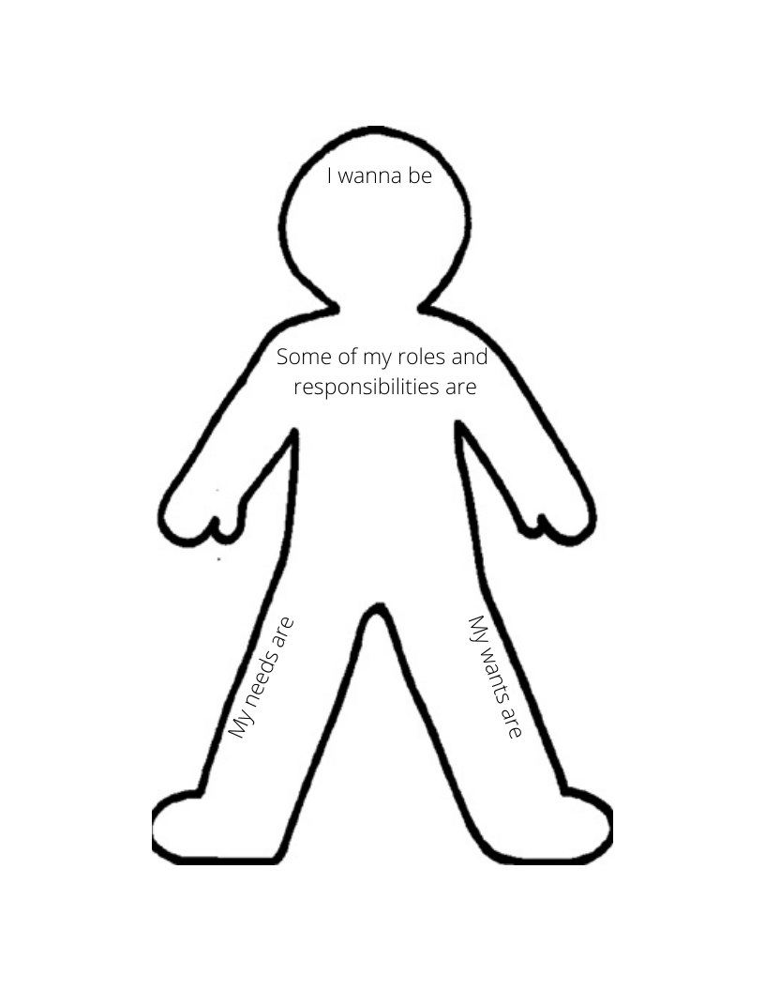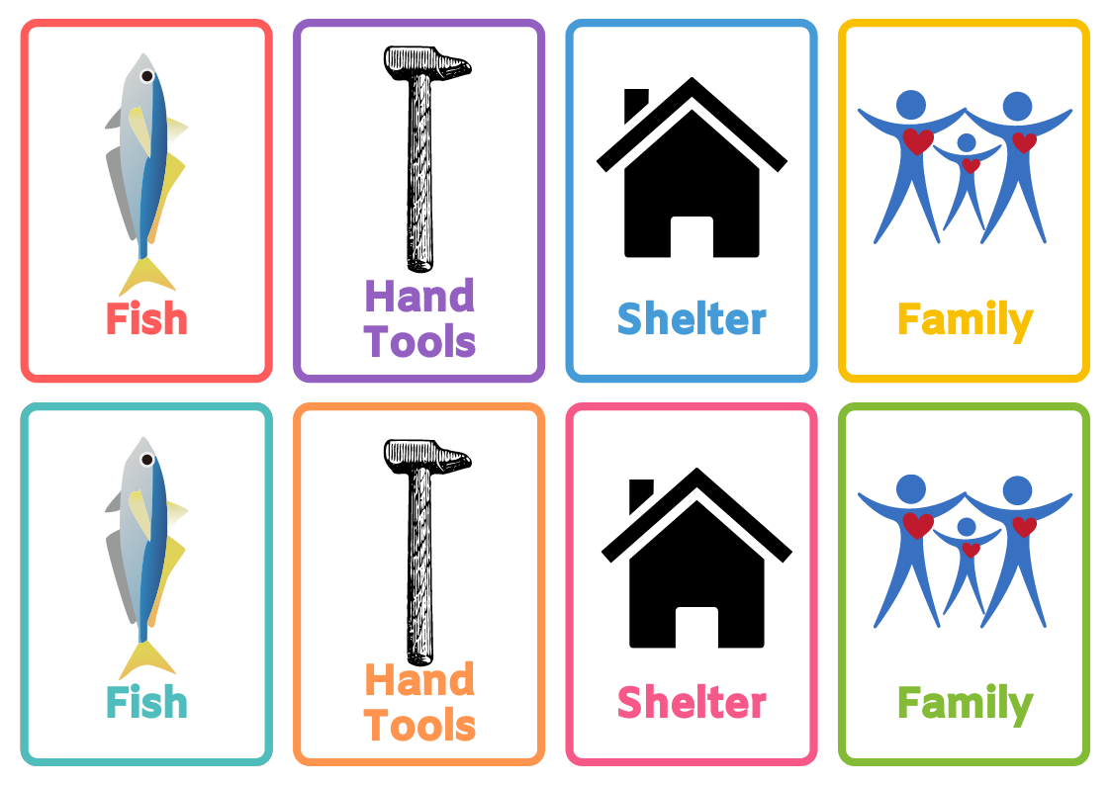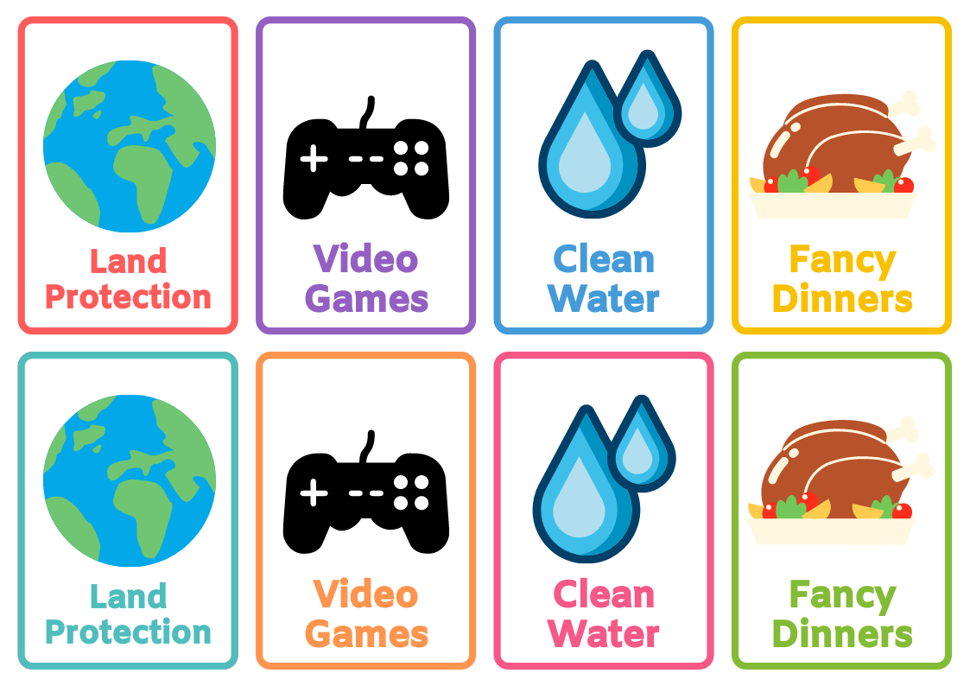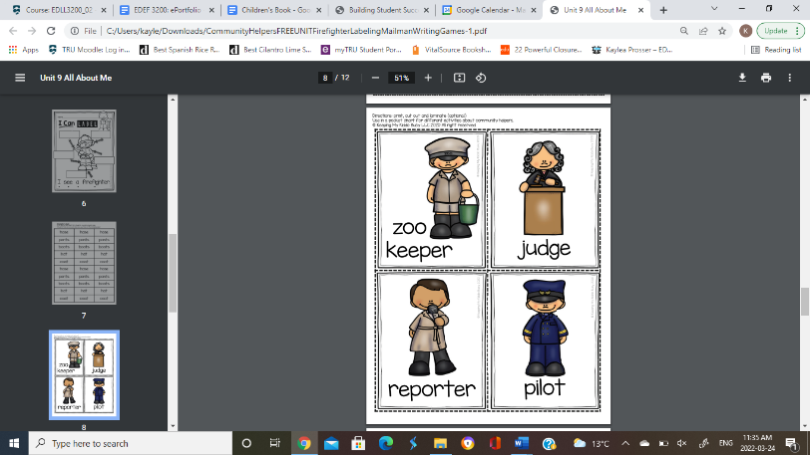
https://docs.google.com/presentation/d/1W0a4AdYWXtdm7SsSw5ow80ii1otwJ7I1dX4e4FhnCpA/edit?usp=sharing needs and wants slideshow
https://docs.google.com/presentation/d/1IB4mmGW0eyoQ6y3_L4y3BSRoARNXAPWzfo4vFjFEqUc/edit?usp=sharing communities slideshow (not completed yet)
https://www.checkli.com/process/6244854ad43b4 (link to my checklist assessment for final project)

Extensions to Unit:
Extensions to this unit could include a deeper connection to the government’s role in needs and wants within both local communities and Indigenous communities. A lesson could also be added on what happens when needs and wants within a community aren’t met. Which would connect better to how the government plays a part in needs and wants in communities. Lastly, another extension would be talking about how population size or geography can change the way people’s need and wants are met or determined.

Reflections and Revisions

